Ideation Phase
Define the Problem Statements

Date | 08 DECEMBER 2025
Team ID (Skillwallet ID) | SWUID202560126
Project Name | Book a Doctor
Maximum Marks | 2 Marks

Customer Problem Statement Template:
To define the core problems patients and healthcare providers face while trying to book and manage medical appointments, and use those insights to guide the development of the Book a Doctor application.
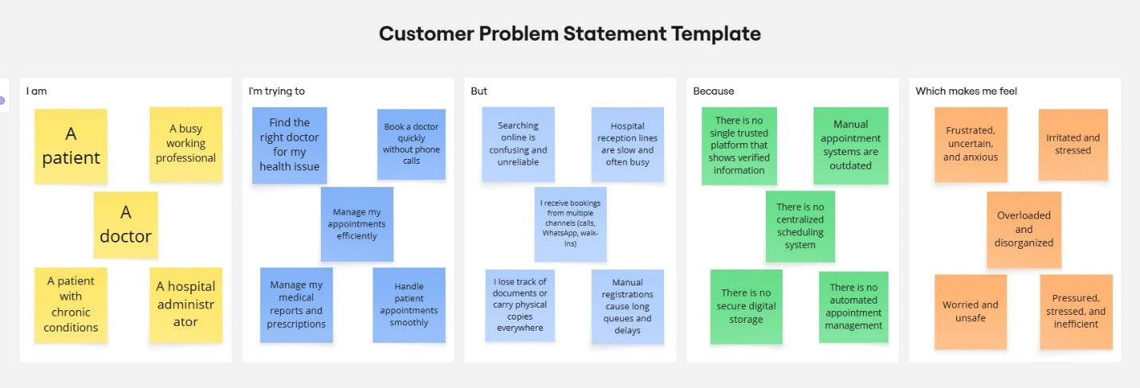

Problem Statement (PS) | I am (Customer) | I’m trying to | But | Because | Which makes me feel
PS-1 | A patient. | Find the right doctor for my health issue | Searching online is confusing and unreliable | There is no single trusted platform that shows verified information | Frustrated, uncertain, and anxious
PS-2 | A busy working professional | Book a doctor quickly without phone calls | Hospital reception lines are slow and often busy | Manual appointment systems are outdated | Irritated and stressed

PS-3 | A doctor | Manage my appointments efficiently | I receive bookings from multiple channels (calls, WhatsApp, walk-ins) | There is no centralized scheduling system | Overloaded and disorganized
PS-4 | A patient with chronic conditions | Manage my medical reports and prescriptions | I lose track of documents or carry physical copies everywhere | There is no secure digital storage | Worried and unsafe
PS-5 | A hospital administrator | Handle patient appointments smoothly | Manual registrations cause long queues and delays | There is no automated appointment management | Pressured, stressed, and inefficient

